How to Change Table Schema

Step 1: Change schema of table in ActiveNetErd.vsd

Tip 1: Open Window of Tables and Views, be easy to select target table or view.

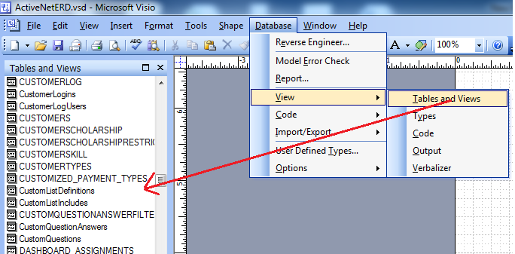

Tip 2: Change driver of Database

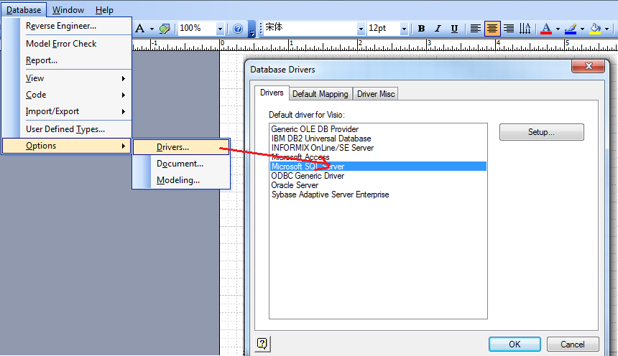

Step 2: Make changes in Vision

Tip: Change data type

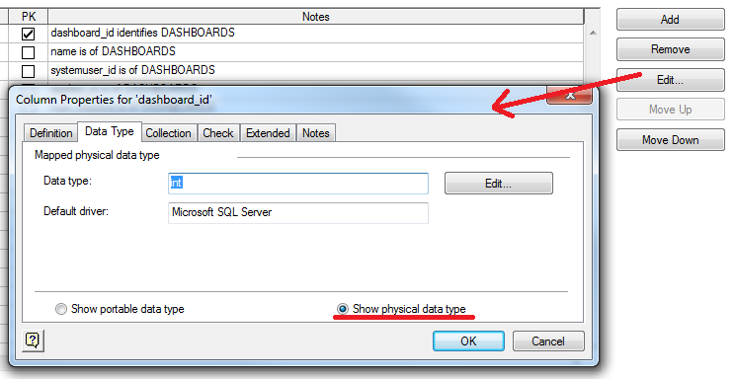

Step 3: Change table Database_Attributes

Change column SchemaLevel_NUMBER to SchemaLevel_NUMBER+1

e.g. SchemaLevel_1932 to SchemaLevel_1933

Step 4: Generate new file.xml

Tip 1: Open AAAExportXml.vsd in same instance of Visio

Tip 2: Do NOT close changed ActiveNetErd.vsd

Expected Result: ActiveNetErd.xml is changed

Tip 3: Run AnUpsizer.exe

Step 5: Change ***required_schema_level*** in SystemInfo.java

Tip: Set value as same as the number of SchemaLevel_NUMBER